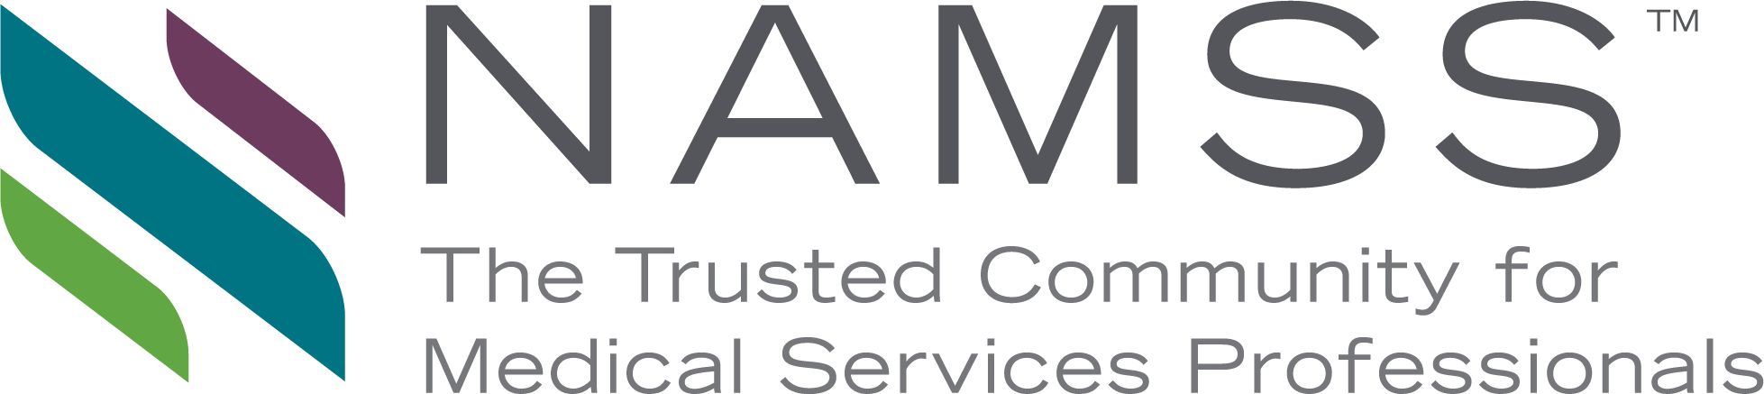

NATIONAL ASSOCIATION MEDICAL STAFF SERVICES
Certifies That

Successfully Completed
Gateway Article: Title
Sponsored by: National Association Medical Staff Services
on
Publication Date
And is hereby awarded 1.0 NAMSS continuing education credits
Accreditation of this educational program
in no way implies endorsement or sponsorship by NAMSS

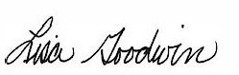
Lisa Goodwin, MBA, CPCS, CPMSM Chair, NAMSS Professional Development Council

